Taxi Booking App

Home Page:-

The below screenshot shows the home page of the Taxi Booking App

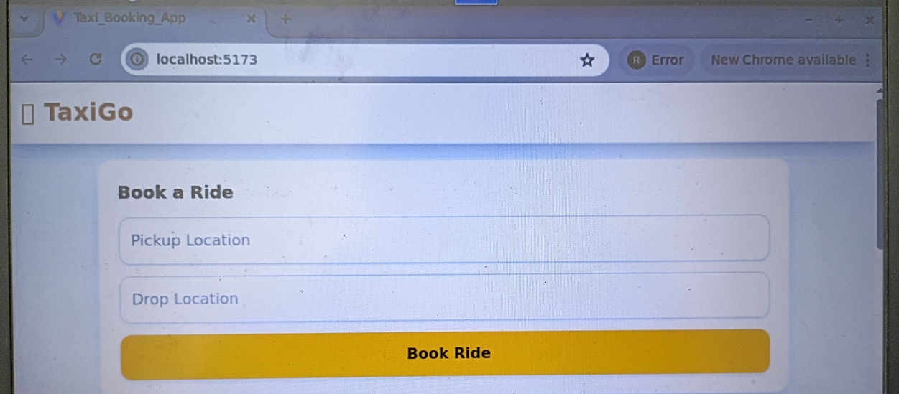

Error Message:-

The below screenshot shows the validation error that pickup and drop location is required.

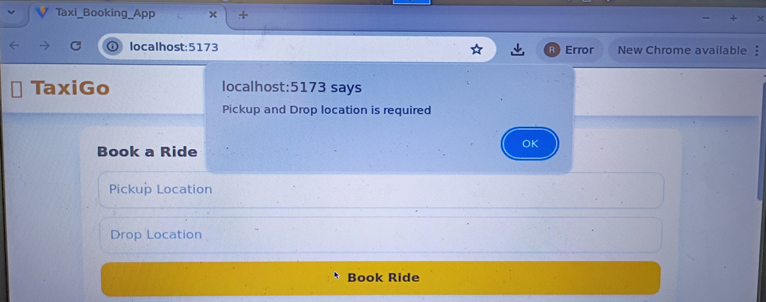

The below screenshot shows the validation error that pickup location is required.

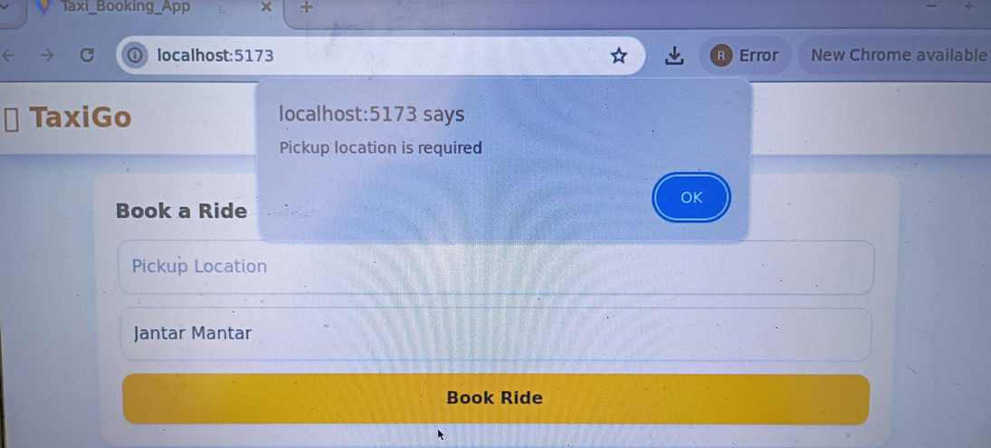

The below screenshot shows the validation error that drop location is required.

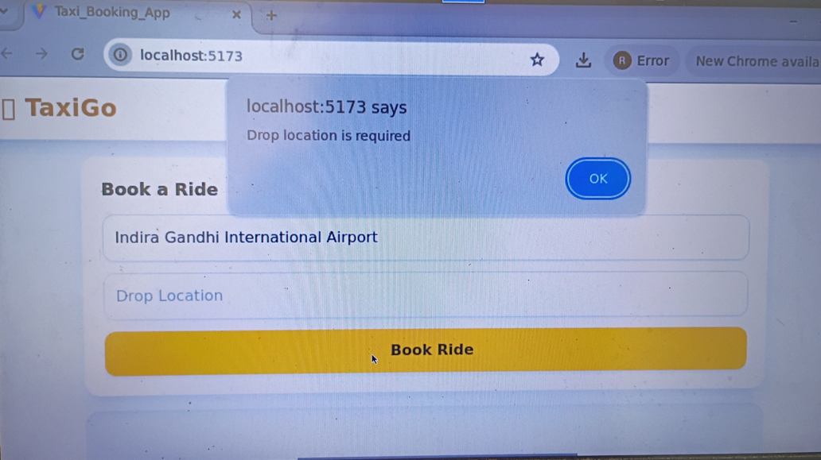

The below screenshot shows the from and to location details entered by the user and the pick up and drop details are mentioned in the message box.

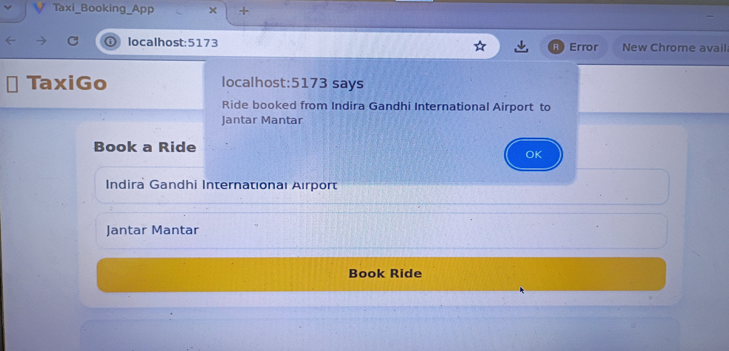

The below screenshot shows the Ride History details.

